# Seminar: KI in logistics

## Project: Guess the number game

### 1.Aim of the project:

Write a python program to develop a game in which the users have to guess a number which the computer generates randomly. The program gives hint on whether the number is greater than or less than the random number generated as long as the user guesses the right number.

### 2.List of features

1. Importing of random method to the program using the import keyword (import random)
2. Generation of the random number by the program
3. Asking the user for input (guessing the number in this case)
4. Using the while loop and combination of if-elif-else keywords to give hints to the user if they have guessed the correct number.
5. The process (in step 4) goes on as long as the user guesses the correct number generated by the computer.

### 3.Basic Algorithm

### 4. The Code

***Note: The entire code was written and tested using command prompt***

**Program:**

import random # importing the random method

number=random.randint(1,100)#generating the random number

guesses=0

while True: #calling while loop

print ('Type 0 to exit the number game') #providing option for the user to quit.

guess=int (input ('enter the number'))

if guess == 0:

print ('Thank you')

break

exit ()

guesses=guesses+1

print ('no.of guesses =', guesses) #printing the number of guesses

if guess<number:

print ('Incorrect, the number is less than the actual number')

elif guess>number:

print ('Incorrect, the number is greater than the actual number')

else:

print ('congrats, you have guessed the right number')

break

### 5. Testing with various inputs

The written code is randomly tested with different values, the screenshots of the outputs are attached below:

**1.**

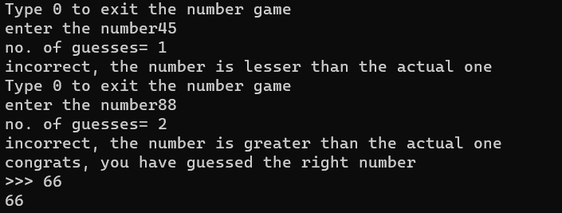

**2.**

**3.**

